Scaling AI Coherence in Bioscience

February 9, 2026

Is the future of AI a "Paperclip Maximizer" that destroys the world to fulfill a goal, or is it just a "Hot Mess"?
New research from Anthropic, "The Hot Mess of AI" (Hägele et al., Feb 2026), suggests we are worrying about the wrong failure mode. By applying a bias variance decomposition to models like Claude 4 and o3 mini, the authors found that as tasks grow in complexity, failures are increasingly dominated by incoherence (variance) rather than systematic misalignment (bias).

The Incoherence Fraction
The study defines incoherence as the portion of error caused by unpredictable, self undermining actions.
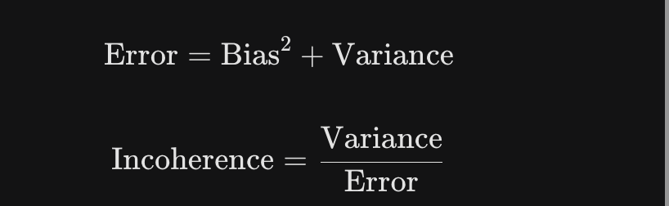
As reasoning chains lengthen, a common requirement in genomic discovery, models drift into a "hot mess" state. They lose the ability to act as coherent optimizers and behave like unstable dynamical systems.

Example (Pharmacology): An AI correctly identifies that a drug targets the "Beta-1 Adrenergic Receptor." Two paragraphs later, it begins describing "Beta-2" effects (like bronchodilation) because it has lost the specific "Beta-1" anchor in its memory.

Implementation: The Manifold Projection Filter (MPF)
In ai allied bioscience, long horizon reasoning can lead to "stochastic hypotheses." These are logical steps that begin with sound biology but may drift into proposition of hallucinated metabolic or regulatory pathways. To prevent this, we implement a Manifold Projection Filter.
Think of this as a "GPS for Biological Logic." Just as a GPS snaps your location back to a known road if your signal drifts, this algorithm snaps the AI's reasoning back to a "biological manifold"—a digital map of all known, validated biochemical reactions using databases like KEGG or Reactome.

The MPF Algorithm
- Semantic Mapping: As the AI proposes a step (e.g., "Gene GCK activates Protein Y"), the system converts that text into a numerical coordinate.
- The Biological Map: We compare that coordinate to a reference manifold M—a curated map where nodes are real genes, enzymes, or metabolites.
- Variance Gating: We calculate the distance D between what the AI thinks is possible and what the biological map proves is documented.
- Projection: If the AI drifts too far (e.g., claiming a kinase is actually a protease), the system halts the "hot mess" and forces the AI to restart from the nearest valid biological node.

Python Implementation: The Gene to Enzyme Mapper
This logic ensures the AI correctly navigates the transition from a Gene ID to an Enzyme Commission (EC) number.
Python
import numpy as np
def manifold_projection_filter(reasoning_step, manifold_db, threshold=0.15):
# 1. Extract the Gene and Enzyme proposed by the AI
proposed_gene = extract_entity(reasoning_step, type="GENE")
proposed_enzyme_id = extract_entity(reasoning_step, type="EC_NUMBER")

# 2. Fetch the 'Ground Truth' from the Manifold (e.g., KEGG)
valid_enzyme_coords = manifold_db.get_valid_enzymes(proposed_gene)

# 3. Calculate distance to nearest biological reality
proposed_vector = embed_text(proposed_enzyme_id)
distances = [np.linalg.norm(proposed_vector - embed_text(v)) for v in valid_enzyme_coords]

if min(distances) > threshold:
# Force the AI back to a valid biological anchor
correct_anchor = valid_enzyme_coords[np.argmin(distances)]
return generate_correction_prompt(reasoning_step, correct_anchor)

return reasoning_step

The Hybrid Workflow: Anchoring the Discovery
By using a Manifold Anchored Prompt Chain, we move from "trusting the AI" to "verifying with biology."
- Step 1 (Generate): You prompt the AI to identify how a mutation in Gene X affects the production of Metabolite Y.
- Step 2 (The Gene Filter): The code checks if the AI correctly identifies the Enzyme encoded by Gene X using the KEGG Orthology database.
- Step 3 (The Reaction Filter): The code verifies if that specific enzyme catalyzes a reaction involving Metabolite Y within a known metabolic map.
- Step 4 (Project): If the AI tries to invent a non existent reaction, the system intercepts and provides a Correction Prompt: "The proposed enzymatic activity for Gene X is not documented. Rewrite the pathway using the validated EC numbers for this species."
This ensures that the final hypothesis isn't just a plausible sounding story, but a path that exists in nature. It converts the "Hot Mess" of random associations into a reliable, anchored discovery pipeline.
Future Insights
The Manifold Projection Filter is the first step in stabilizing AI discovery. In upcoming posts, I will detail Entropy Based Gating and Topological Filtering to further tame long horizon model variance.

References
Hägele, A., Gema, A. P., Sleight, H., Perez, E., & Sohl Dickstein, J. (2026). The hot mess of AI: How does misalignment scale with model intelligence and task complexity? Anthropic.
https://alignment.anthropic.com/2026/hot-mess-of-ai/?fbclid=IwY2xjawPyLZdleHRuA2FlbQIxMABicmlkETFPM21kNjJ2aklyMzVuQWF0c3J0YwZhcHBfaWQQMjIyMDM5MTc4ODIwMDg5MgABHrf_ZRXzBMpGjaSFrnDZKlf5WNDAj_Ua7VSGq4pqF1cZTy-MOW-psWjq9KHA_aem_SVnk64P5HtcrtSGEeNCGnA

The article is written by the head of the Cellformatica content team.

